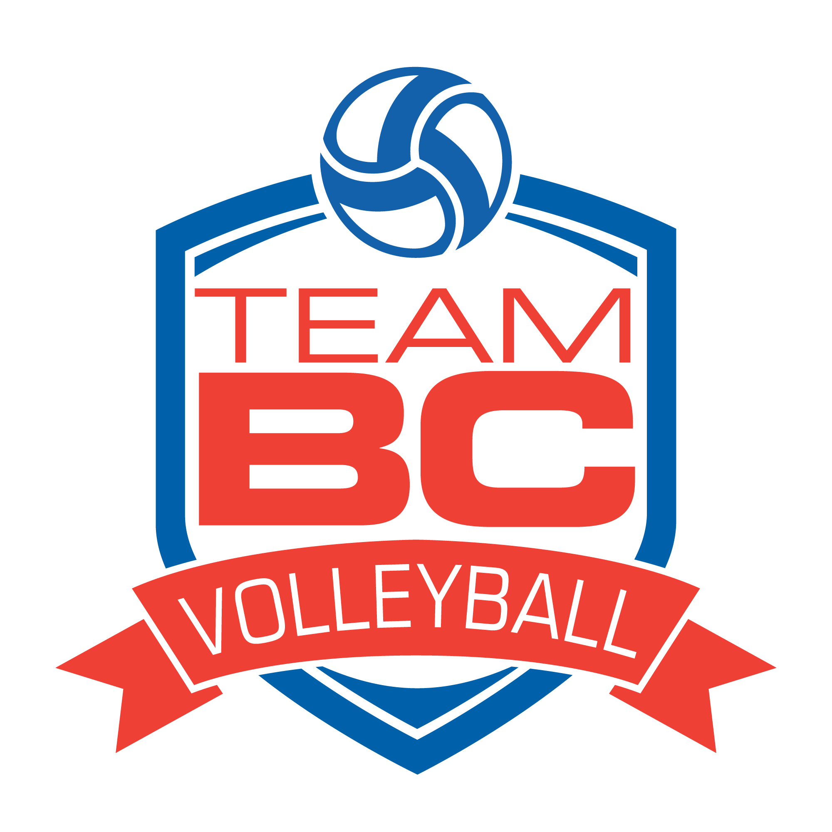
Team BC Zone Program
North Training Schedule
Full Team BC Zone program details can be found here - https://www.volleyballbc.org/team-bc/teambc-zone-program/
Boys Schedule
Dates | Times | Location
June 18/19 | 11-1 pm & 3-5 pm both days | College of New Caledonia, 3330 22 Ave, Prince George, BC V2N 1P8
June 25/26 | TBD, programs will be schedule for 1-2 x 2 hr sessions /day | College of New Caledonia, 3330 22 Ave, Prince George, BC V2N 1P8
July 9/10 | 11-1 pm & 3-5 pm both days | College of New Caledonia, 3330 22 Ave, Prince George, BC V2N 1P8
July 16/17 | 11-1 pm & 3-5 pm both days | College of New Caledonia, 3330 22 Ave, Prince George, BC V2N 1P8

Girls Schedule
Dates | Times | Location
June 18/19 | 9-11 am & 1-3 pm both days | College of New Caledonia, 3330 22 Ave, Prince George, BC V2N 1P8
June 25/26 | TBD, programs will be schedule for 1- 2 x 2 hr sessions /day | Dawson Creek Secondary South Peace Campus. 10808 15 St, Dawson Creek, BC V1G 3Z3
July 9/10 | 9-11 am & 1-3 pm both days | College of New Caledonia, 3330 22 Ave, Prince George, BC V2N 1P8
July 16/17 | 9-11 am & 1-3 pm both days | College of New Caledonia, 3330 22 Ave, Prince George, BC V2N 1P8
Tentative schedule, subject to change

