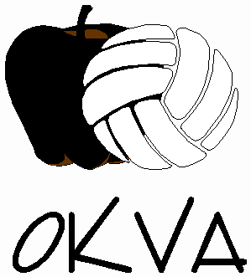
The Okanagan Volleyball Association’s Beach Volleyball Club is a great way for beach athletes to advance their beach volleyball skills and for new athletes to acquire skills specifically for beach volleyball.

2019 OKVA Beach Volleyball Club
The OKVA Beach Volleyball Club focuses on developing beach volleyball athletes and training beach volleyball skills. Our coaches have both training and experience in beach volleyball and are dedicated to improving your skills through fun drills and games.
Age: 12-15 years old (born in 2004 or later)
Location: City Park, Kelowna
Dates: June 3rd-June 27th, 2019 - Mondays (Beach Volleyball) & Thursdays (Grass Volleyball)
Times: 4:00pm-5:30pm
Cost: $100.00 (cash or cheque); payable to Okanagan Volleyball Association (OKVA), due June 3rd.
Note: Athletes may register individually; they do not need a partner.

Register early! This club fills to capacity every year. First come, first served registration.
Registration Form
Name: Click here to enter text. Female: ☐ Male: ☐
Birthdate: Month: Choose an item. Date: Choose an item. Year: Choose an item.
Phone: Click here to enter text.
Email Address: Click here to enter text.
City: Click here to enter text. 2019 Club Team: Click here to enter text.
Medical Services Card Number: Click here to enter text.
I am the legal guardian of Click here to enter text., I have read the enclosed information and give permission for my daughter/son to participate in the OKVA Beach Volleyball Club.
Parent/ Guardian: Click here to enter text.
Return completed form and cheque to Okanagan Volleyball Association (OKVA) via email okanaganvolleyball@gmail.com or mail: 726 Glenwood Avenue, Kelowna BC V1Y 5M5

