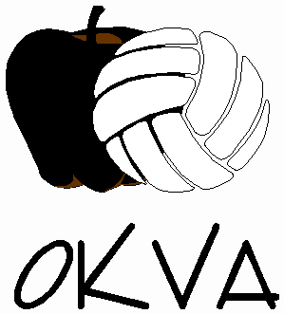
The Okanagan Volleyball Association’s Beach Volleyball Club is a great way for both existing and new athletes to acquire and advance their beach volleyball skills. With a focus on development and training, our coaches have a wealth of experience in beach volleyball and are dedicated to cultivating their beach athletes through fun and engaging drills and games. This year’s OKVA Beach Volleyball Club will take place half on grass and half on the beach. In this way, athletes will be given a chance to enhance their beach volleyball tactics in two locations.

2018 OKVA Beach Volleyball Club
Age: 12-15 years old (born in 2003 or later)
Location: City Park, Kelowna
Training Sessions: Mondays & Thursdays; 4:00pm-5:30pm
- Mondays (June 4th, 11th, 18th and 25th) - Grass Volleyball @ North Field, City Park
- Thursdays (June 7th, 14th, 21st and 28th) - Beach Volleyball @ Hot Sands Beach, City Park
Cost: $80.00 (cash or cheque); payable to Okanagan Volleyball Association (OKVA), due June 4th, 2018
Note: Athletes may register individually; partners are not required.
Register early! This club fills to capacity every year. First come, first served registration.
Registration Form
Name: Click here to enter text. Female: ☐ Male: ☐
Birthdate: Month: Choose an item. Date: Choose an item. Year: Choose an item.
Phone: Click here to enter text.
Email Address: Click here to enter text.
City: Click here to enter text. 2018 Club Team: Click here to enter text.
Medical Services Card Number: Click here to enter text.
I am the legal guardian of Click here to enter text., I have read the enclosed information and give permission for my daughter/son to participate in the OKVA Beach Volleyball Club.
Parent/ Guardian: Click here to enter text.
Return completed form and cheque to Okanagan Volleyball Association (OKVA) via email or mail @ okanaganvolleyball@gmail.com or 726 Glenwood Avenue, Kelowna BC V1Y 5M5

